Week 2 assignment

1. Introduction of random event both in time and frequency domains

When there is an actual system, and we want to understand the dynamics or to acquire the output on a basis of the input, two domains, which are time domain and frequency domain, could be chosen. However, if we only use the differential equation to model the system dynamics, which represents the analysis in the field of time domain. On the other hand, if we make use of Fourier transform, the problem belongs to the field of frequency domain. Searching a solution in time domain is difficult since one needs to assume the solution in advance. Instead, getting a solution in frequency domain when the equation belongs to a polynomial is much easier.

Since signals are decomposed in frequency domain, we can make use of window functions, such as rectangular, Hanning, flattop etc. window functions to assure their stability. Since we couldn’t obtain the full signal length which possibly is mingled with disturbance, we select the right one depending on the different type of signal sources.

A band-pass filter is a technique that filters out signals of other frequency bands while leaving only the signals of a specific frequency band and is applied widely to the filtering of signals [3]. In order to differ a range of frequency of signal sources, which are normally divided into narrow band and broad band, we get them according to the width of channel. For example, the fatigue initiation life can be estimated by combining the stress spectra and S-N curves assuming linear cumulative damage and a narrow-banded response.[2]

We consider the part of the assignment corresponding to ‘Multiple Sinusoidal Signals’ is more interesting for the scope of the project and the course, and there we developed MATLAB models which aims to validation of our assumptions, taking into consideration that the signal source of the broadband is the same.

1. Single-degree-of-Freedom Linear System
   1. Equation of motion and response on harmonic excitation

The objective of the first part of assignment was to study the effect of forced excitation and damping in 1-DoF linear system in time and frequency domain. The linear system is a simple spring damper harmonic oscillator. In order to create a simulation of the system, differential equation of motion of the harmonic oscillator was defined. The equation of the motion is defined as



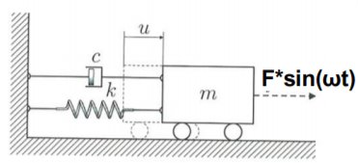

Figure 1. A simple 1-DoF spring damper mass system.

m is mass of load；

c is damping coefficient;

k is stiffness of the spring;

w is frequency of the system;

Fsin(wt) is harmonic force excitation to the system.

Response of system to forced vibrations is derived as sum of a transient part u(t) and a steady-state part u_p(t).



, where a is amplitude of motion, Φ phase angle and ξ viscous damping ratio and

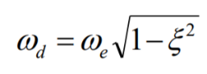

, where ω_e is eigen frequency of the system.

Figure 2 represents response of the system with the transient and steady part separately plotted. From the graph it can be noted that the transient and steady part eventually meets resulting in a stationary response. This is a common example of a random load that can potentially happen when a system is initialized, commonly “assumed” as a starting phase phenomenon and neglected.



Figure 2. System response on harmonic force excitation. The response is split in steady state, transient state and stationary state.

* 1. Frequency and Amplitude from Stationary State

A signal can be transformed from time domain to frequency domain with Fast Fourier Transformation (FFT). By transforming the output signal of the system, eigen frequency of stationary part can be derived. The graph below (Figure 3) correctly displays the frequency of stationary part in the spectrum (equals to the frequency of the excitation force) and the amplitude of stationary part. The correctness depends on the chosen sampling frequency and on the length of the signal.

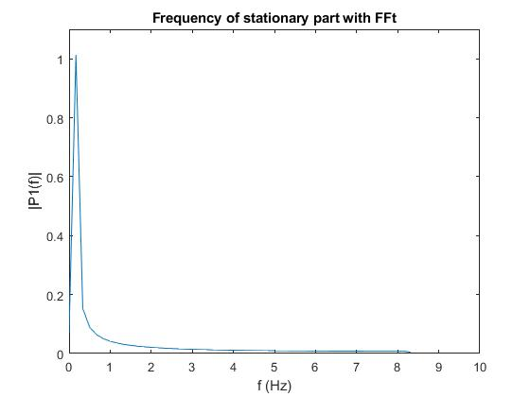

Figure 3 frequency of stationary part after applying FFT

In the figure below (Figure 4) is displayed transformation of response of entire system from time domain to frequency domain. These displayed data are very similar to the previous plot (Figure 3) due to a fact that stationary part is dominant in the system response. The amplitude is slightly higher than in the previous case because of the transient part. Frequencies of transient part and stationary part are close to each other and that is the reason why we can see a resonant response (only occurs at the beginning of the process).

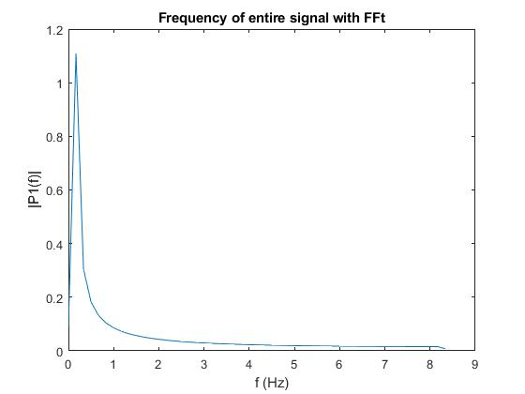

Figure 4 frequency of stationary part after applying FFT

1. Sum of multiple signals

The FFT performed in previous section shows the utility of the algorithm. FFT can be even more useful in postprocessing when the signal has more then few output signals. Furthermore, system response signals have natural noises in real life application due disturbances from outside of the system. The noises can cause significant distortion in the analyzed signal which complicates signal processing. However, with help of FFT, the noise level and main frequencies of the system can be extracted from the analyzed signal.

* 1. FFT in signal post processing

The purpose of this part of assignment is to show how FFT can be harnessed for signal processing in order to extract primary data by decomposing the analyzed signal. The initialization of the task is done by creating few random sinusoidal waves with different amplitude, phase shift and frequency values. In addition, an artificial zero-mean white noise signal was created to disturb the signal. (Figure 5) Then, the signals were summed together to create the analyzed signal for FFT. The signal representing the sum of sinusoidal waves and noise is displayed in Figure 6.

Frequencies: f1 = 4 Hz, f2 =30 Hz and f3 =100 Hz

Amplitudes: a1 = 2, a2 = 1 and a3 = 0.7

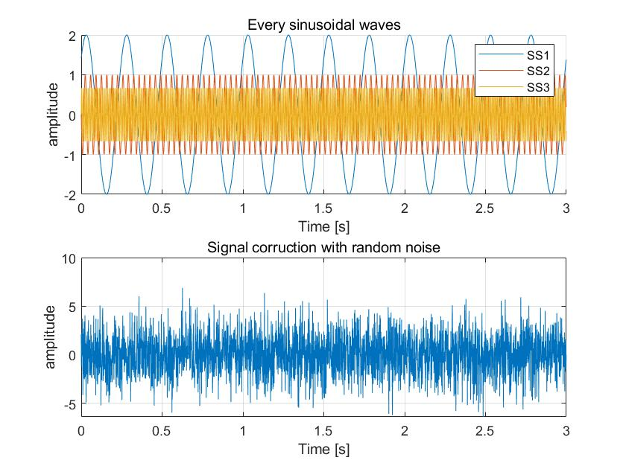

Figure 5. Upper graph, Random generated sinusoidal waves. Lower graph, random generated white noise for signal corruption

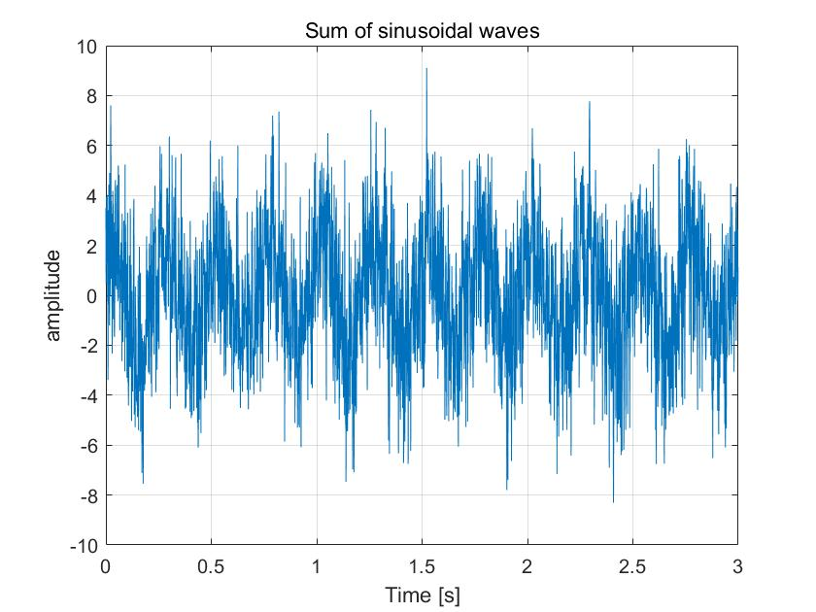

Figure 6. sum of sinusoidal waves and signal corruption.

Then FFT is applied on the sum signal which result is displayed Figure 7. Each of frequencies and the responding amplitude of the sinusoidal waves can be seen from FFT graph. There are few things which can be noticed from the graph. Firstly, the amplitudes of each wave signal are slightly changed by the added noise signal. This is due the fact that the noise signal may include parallel frequencies with the sinusoidal waves which then adds up to the amplitude of each peak. Secondly, the noise signal can be clearly seen from the graph as the minor random peaks excluded from the three peaks.

Frequencies: f1 = 4 Hz, f2 =30 Hz and f3 =100 Hz

Amplitudes: a1 = 2, a2 = 1 and a3 = 0.7



Figure 7. Result of FFT on sum of signals including sinusoidal waves and white noise.

* 1. Narrow and broad banded process

In some occasions, we may have a specific range of signal frequency spectrum. In this report, two extreme range spectrums are focused on which are narrow-banded and broad-banded process. A narrow-banded process has very narrow frequency band and a zero mean. Whereas, a broad-band process has a large window of frequencies which may cause difficulties to achieve zero mean since it will vary over long time. Figure 8 displays a narrow-brand process and FFT plot of sum of the narrow-band signals. Figure 9 displays a broad-brand process and FFT plot of sum of the signal.



Figure 8. Narrow-band process on left side. FFT plot of the process on right side.



Figure 9. Broad-band process on left side. FFT applied on the process on right side.

The signals described above are not guaranteed to be fully clean or in other words have no leakage to the frequency plot. The leakages can be cause e.g. not sampling over full wave lengths. In order to get rid of the leakage, windowing technique can be applied to the signal before FFT. The basic idea behind windowing is to have a moving multiplier for processed signal. The multiplier then starts and ends with zero. Hann windowing technique is used in this report which is displayed in Figure 10.



Figure 10. Hann windowing for cleaning the signals. The window sample rate is equal to sample size of each signal.

To study the effects of windowing, Hann windowing was applied on the broad-band process. The results of Hann windowing on time domain can be seen in Figure 11 and frequency domain in Figure 12. From graph of FFT on broad-band process shows clearly that the peaks in FFT plot with windowing have cleaner peaks compared to FFT plot without windowing.



Figure 11. Hann windowing on the broad-band process signal in time domain. Left is without windowing; right is with Hann windowing.



Figure 12. Effect of Hann windowing on broad-band process signal in frequency domain. Left is without windowing; right is with Hann windowing.

1. Freak event

For the freak event in the wave spectrum, it seems like an abnormal peak value, when many sinusoidal spectrums accelerate together in a moment, such as 10 signal sources disseminate along an axis. Depend on the difference of phase, those spectra will create the effectiveness of addition and odd kurtosis, but it will be created by the characteristics of spectrum.[1] [4] In MATLAB, 10 sinusoidal waves are created with a succession of fluctuated and unsteady phase. Then the wave signals are added together. The signals and sum of the signals can be seen in Figure 13. A freak event approximately at time t=5s, when all signals have their peaks at the same time.Figure 13. freak event

Figure 13. freak event plot with 10 different sinusoidal waves. Lower graph displayed sum of signals of upper graph,

* 1. Likelihood in practice

Because a freak event, e.g. freak wave, can possibly cause a huge damage to ship or another construction, engineering goal is to estimate if there is possible danger of freak event. According to article [4], we can calculate exceedance probabilities of specific critical wave crest amplitude in order to anticipate occurrence of freak event and these probabilities are directly related to the occurrence of freak waves. In the practical application we usually have information about a specific wave spectrum, so we must forecast the occurrence probability of freak waves in the sea only based on wave spectrum. It is possible to use for prediction wave elevation time series too, but that method is expensive and time-consuming.

In the figure 13 [4], there is comparison of different approaches for computing the wave crest amplitudes exceedance probabilities.

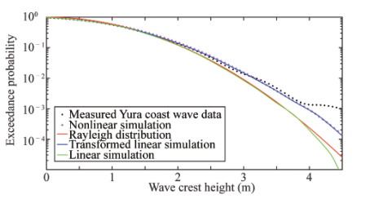

Figure 13. Comparison between wave crest amplitudes exceedance probabilities from different simulations [4]

* 1. Roles of time and frequency domain during design process

In time domain, we could get a series of amplitudes while in the frequency domain a range of frequencies as well as amplitudes can be observed. With the help of frequency domain analysis, we could observe some spectra that might have disappeared.

Considering an example of a specific situation, we talk about and abnormal wave in the ocean. In time, the abnormal wave happens at exactly the moment in which the series’ highest peak of energy exists and has a frequency equal to the frequency of the usual stationary spectrum, which could not be searched in frequency domain [1].

Apart from that, in cases where latching control is applied. We shall assume that amplitudes of waves and oscillations are sufficiently small enough, and they could be ignored with the continuous time, which could cause some points lost in time domain. At that situation, the system is not time invariant. Latching control is used to achieve the same phase in a system with the loading of the system in which the time possibly is variant. Then instead of studying dynamics in the frequency domain only, it is better to apply time-domain analysis [5].

**Reference**

[1] Cherneva, Z. & Soares, C. (2014). Time-frequency analysis of the sea state with the Andrea freak wave. Natural Hazards and Earth System Sciences, 14(12), p. 3143. doi:10.5194/nhess-14-3143-2014

[2] Thompson, I. (2016). Validation of naval vessel spectral fatigue analysis using full-scale measurements. Marine Structures, 49, pp. 256-268. doi:10.1016/j.marstruc.2016.05.006

[3] Kim, Y., Kim, B., Choi, B., Park, S. & Malenica, S. (2018). Analysis on the full scale measurement data of 9400TEU container Carrier with hydroelastic response. Marine Structures, 61, p. 25.

[4] Wang, Y. Estimation of Wave Crest Amplitudes Distribution and Freak Wave Occurrence in A Short Crested Mixed Sea. *China Ocean Eng* **33,** 484–492 (2019). https://doi.org/10.1007/s13344-019-0046-0

[5] Falnes, J. (2007). A review of wave-energy extraction. Marine Structures, 20(4), pp. 185-201. doi:10.1016/j.marstruc.2007.09.001